Music Education Network - for The Visually Impaired -
An International Coalition of Parents, Educators, and Students
- MENVI Headquarters -
Southern California Conservatory of Music – PO Box 408, Burbank, CA 91503
Phone: (818) 704-3819; E-mail: <richardtaesch@menvi.org>
Website: www.menvi.org
News Journal – Spring 2010 | Issue 30
M E N V I
- Announcements: Training; Online News; Teaching Piano Formats Continued -

TEACHER TRAINING COURSE

“An Introduction to Music for the Blind Student,” Part III is nearing publication. It has been long awaited, and will soon become available through Dancing Dots, the publisher (www.dancingdots.com).
Part III is quite different from its predecessors in several ways. The primary difference is that Part I and Part II are each dedicated to the tutor or teacher who may not know any braille or braille music. Teachers learn along with their students in the early reading process. There are lessons, assignments, and theory exams prepared for the student and the teacher to use.
Part III is an extensive teacher-training course consisting of over 500 print pages. An Appendix includes answers to the Theory Examinations in Part I & II; there are self tests for those preparing to become music braille educators, and a separate Answer Key provides answers. The approach also provides opportunities for structuring of course proposals and syllabi for various kinds of class work.
Teachers who have guided a blind student through the process of Part I & II, and who may wish to pursue a professional career of teaching music braille, are typical candidates for the course. Resource and VI teachers can also benefit from the course even if only teaching an occasional music student.

NEWS JUST FOR ONLINE MEMBERS

There have been requests for regular information in the news journal dedicated specifically to online and subscription issues. Since many of our members access MENVI services this way, we will begin a short series just for online users.
There are several items of importance for online members: (1) Addresses: If you would like an email address on our domain to contact staff, call Jared at: 818-921-4976 or toll-free 866-824-7876. If you reach Jacob Sexton, our list manager, he can review your request. (2) Messages: If leaving a voice mail, be sure to leave an evening phone number; calls cannot be made past 10 pm (your time zone). International callers, kindly leave your entire phone number including international codes; effort is made to return all calls within 24 hours. (3) Info: Jared or Jacob will ask you to provide a username and a password. Make sure the password is secure with upper and lower case letters and numbers where possible. Our system may not allow simple passwords that are not secure. You’ll need to leave contact information for someone to confirm that your request is complete. You’ll also be provided with servers and other information that you will need.
This is a free service to members. Each account is subject to certain conditions: (1) Please be responsible for your incoming and outgoing mail. We will never attempt to look at your mail. (2) Each mailbox has a 25MB limit; we recommend no more than 10MB for efficiency, but we can increase the size if you like.
As to the downloads page, some of you have accounts on this system where you enter a username and password to access rosters. This system is used to download news journals as well, but it has changed. The journals are public information, and starting with issue 28, we offer PDF documents and braille files for download or viewing. To access the rosters you must have an account. Call Jared at 818-921-4976 or toll-free 866-824-7876 for details. In the next issue, we’ll continue our discussion, including privacy policy, and more. Feel free to contact the Webmaster at the above phone numbers, or jaredr80 skypeE-mail: contact@menvi.org

Jared Rimer - MENVI Webmaster

TEACHING EARLY PIANO FORMATS TO A BLIND STUDENT … Continued

Article adapted from CTEBVI Journal (formerly CTEVH), Summer 2009 – with permission

CTEBVI stands for California Transcribers and Educators of the Blind and Visually Impaired. It is open for membership to all who are interested in the educational welfare of blind individuals. www.ctebvi.org

Let us expand our discussion of teaching reading skills for bar-over-bar piano music formats.
Continuing with an example from “Introduction to Piano for the Blind Student” - Graded Studies Book 1, the first experience with two hands simultaneously appears on Page 7. In measure 7, there are notes written in both the right and left hand parts. They are exactly the same notes played one octave apart. For our purposes, we refer to them as “unison hands,” even though true unisons in the same octave are not possible on the piano.

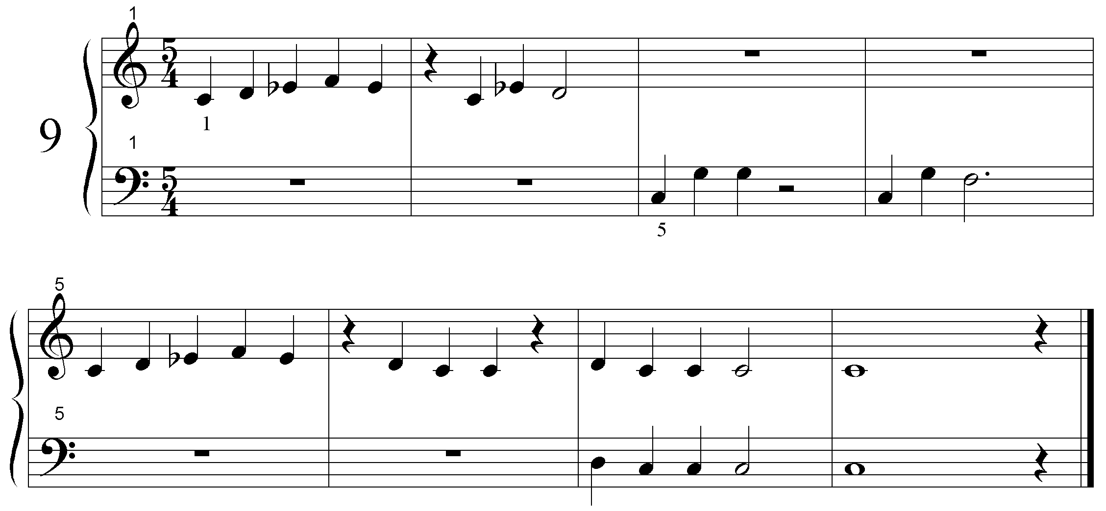

#E4
A .>"?A:<$]$ V"?<$O M M
_>'M ''''' M _?K\\U _?\Q'

E .>"?:<$]$ V":??V ":??N "YV<K
_>'M M _:??N _YV<K
▲ both hands together

Once the student has read hands separately as indicated in the last journal article, he or she has become aware that two hands will be played together in measure 7. Even with shoes and sox intact, assembly of the two parts will be quite easy once the reader sees that both hands play the same notes.
One suggestion is to touch the right hand part with the right hand, and the left hand part with the left hand at the same time. Encourage your student to imagine the bar-over-bar position of the notes in both hands before playing them together.
We must exercise much patience when teaching coordinated hands with music braille. Although piano music is the most challenging of braille music formats for the blind reader, with practice he or she will soon gain much proficiency in reading and playing in this format.
Here is another example from Graded Studies, however, this time measure 8 requires that different notes be read and assembled.

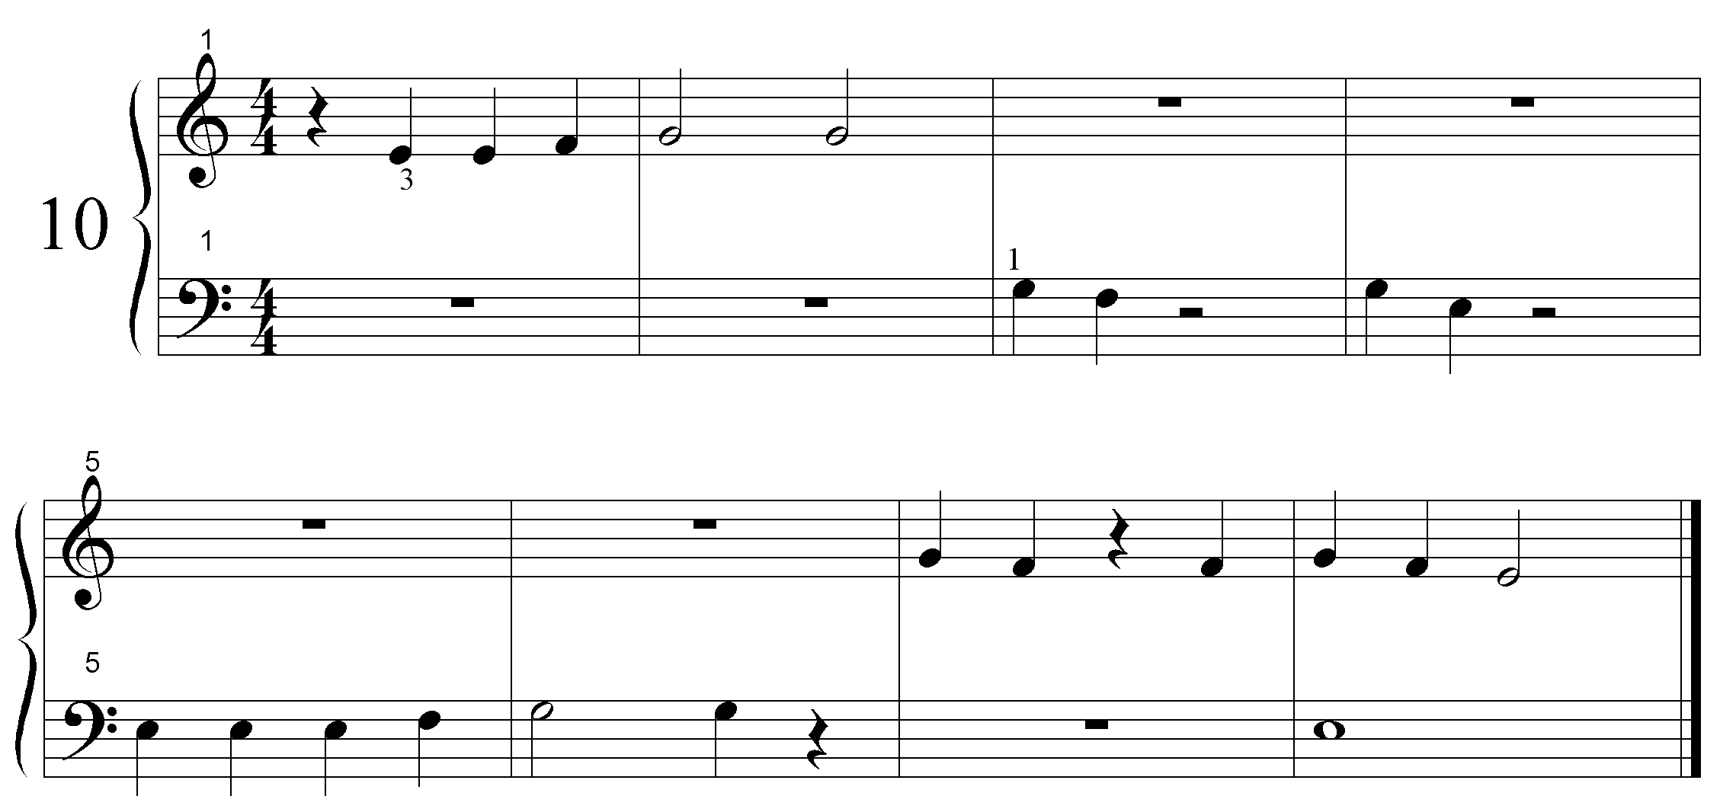
#D4
A .>'V"$L$] "RR M M
_>'M M _\A]U _\$U

E .>'M M "\]V] "\]P<K
_>_$$$] _\\V M _&<K
▲ both hands, different notes

Special Reviews:

CALIFORNIA STATE UNIVERSITY, STANISLAUS – A ROLE MODEL

Some time ago, we reviewed New England Conservatory of Music for its fine program and services for blind music students. NEC is a prestigious music conservatory known the world over; it has no formal department or technology for blind students, and yet has served several with the greatest of success. Foresight, along with the ability to plan ahead and seek the expertise of outside braille specialists, has produced top quality music majors including graduate studies and doctoral candidates. Education comes first, and the results speak for themselves.

Cal State University at Stanislaus deserves the role model award for this issue. When CSUS first admitted a blind music major named Rachel, the DSS officer was completely at a loss of what to do. She made contact with a music braille specialist, and being a true and knowledgeable professional, accepted and followed suggestions and guidance. The story is simple and need not be told in detail; the student is in her third year as a Vocal Arts major, and has been extremely successful. Our DSS officer simply plans ahead, and insists that syllabi be provided for the transcriber, while using technology to provide text portions of textbooks. The transcriber is able to keep up with class dates by only being responsible for music portions of books. Class quizzes are provided well ahead of test dates, and vocal repertoire is acquired as early as possible.
Conversely, so many failures have occurred where DSS officers were so confident that they could handle everything on their own, and that technology would solve everything. So wrong have they been, that one situation inspired the little book, “A Blind Music Student’s College Survival Guide.” (Available for free download at www.menvi.org)
Congratulations to CSUS, NEC, and all the wonderful schools who are dedicated to their students, believing that a blind student can indeed succeed, and work as well, if not surpass the expectations and accomplishments of any student! To be continued …

Reminders: Would you like to see articles of your own published? Are there other issues that you would like to see addressed in your Journal? If so, take some time to let us know your needs. Or, contribute your own article proposal to MENVI Headquarters!

Is your membership roster information up to date?
Be sure to fill out an updated application online, or ask Jared to fax one to you

